HW3 - Question 4 – Pac Learning

1. Suppose we have the classifier family: where iff . In order to find the VC dimension of this classifier family we need to understand it’s capabilities, we find the maximum amount of data points classifiers from can classify to every possible combination of classes. Let’s take as an example:

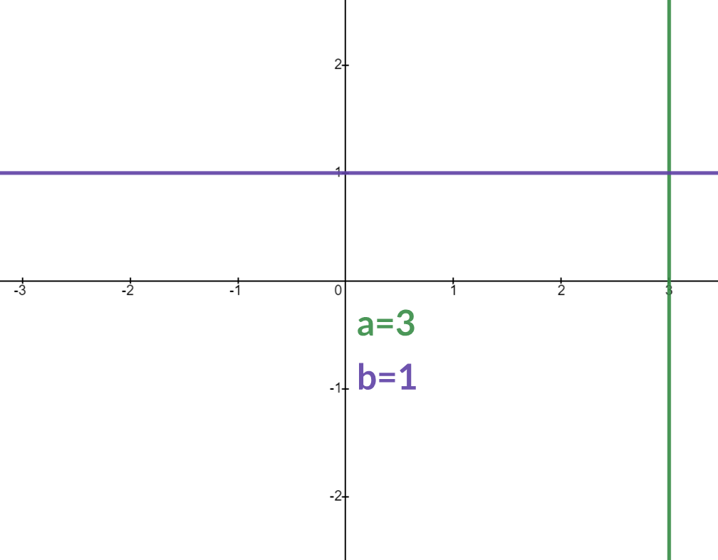

In this example the area where the classifier returns 1 is when, the area marked in red:

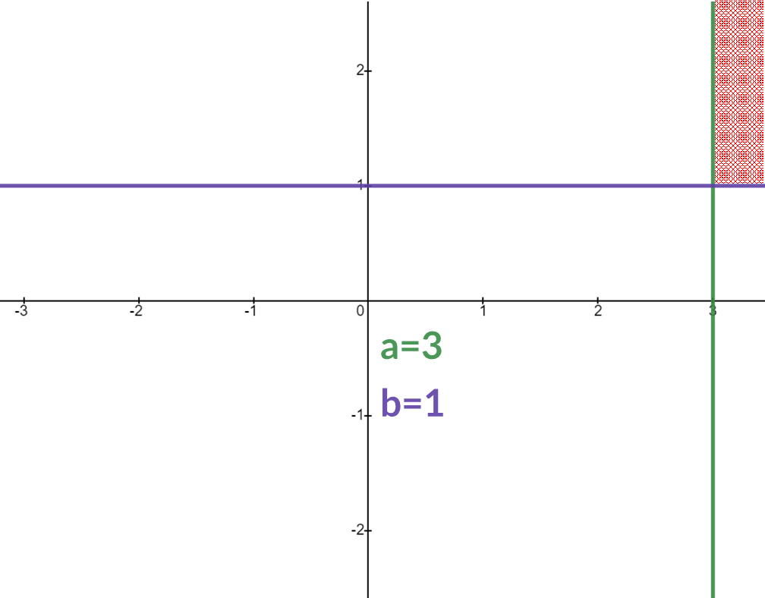

We will show that shatters every group of 4 samples but not every group of 5 samples, hence the VC dimension would be 4.